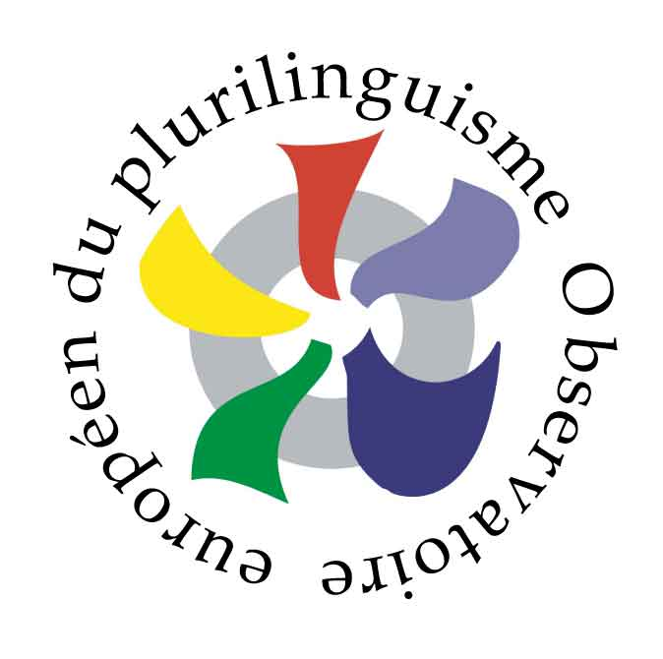 | 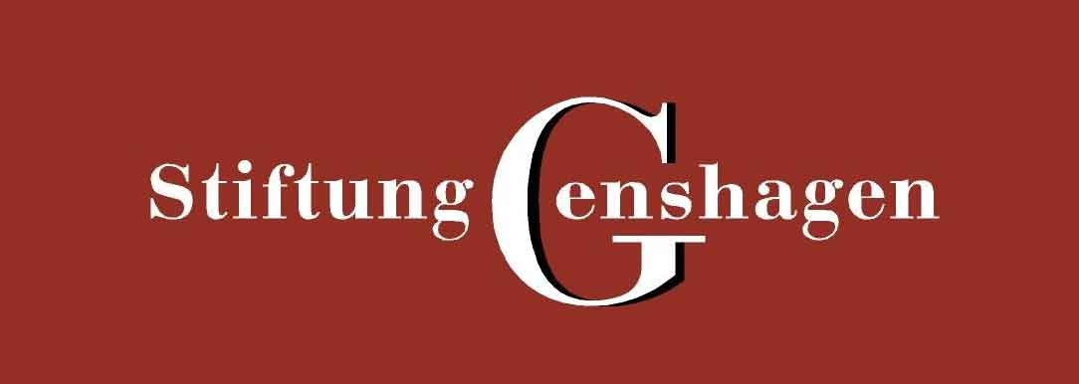 | 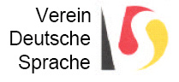 | 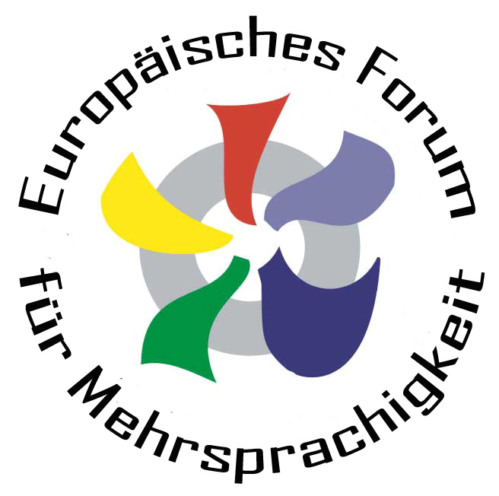
2e Assises européennes du plurilinguisme
2. Europäische Tagung für Mehrsprachigkeit
Berlin/Genshagen 18.-19. juni 2009

INTRODUCTION
The 1st European Conference on Plurilingualism was held on November 24-25 2005 at the Ecole Normale Supérieure and at the Palais du Luxembourg in presence of policymakers, researchers and many civil society actors coming from some ten European countries.
The 2nd European Conference on Plurilingualism will be held in Berlin on June 18-19 2009, hosted by the Genshagen Foundation and the Berlin city council.
The Conference is systematically based on research works because political choices have to be explained by scientific works. The research is obviously neutral in its methods, but cannot be neutral in its goals and orientations.
The Conference is a particular moment within a global action, the aim of which is to promote plurilingualism in Europe and, from then on, authentic citizenship, both national and European.
The Conference brings concrete results based on and following discussions in workshops. In 2005, it allowed the creation of the European Charter on Plurilingualism. The Conference expects and studies precise practical situations with short-, medium- and long-term basis effects.
Uniting Europe using the economy and one single language would be a mistake, all the more so because is it a minority language within Europe. Europe is not a victim of its linguistic and cultural diversity. Quite the opposite, it is an exceptional wealth that we need to develop by all possible means and which provides a basis for further construction.
During the Conference, we invite every civil society actor and every political and administrative representatives to reflect on questions that, in our mind, are the most sensitive or need developing.

SELECTED THEMES
1- Citizenship : language, mobility and culture
Its aim is to move away from an all too functional and simplistic conception of language, which would reduce the very objective of cultural and linguistic diversity as well as of intercultural development. What is the use of diversity if languages and cultures can be standardised? (see thematic sheet). On the contrary, language, as a vector of culture, is the necessary means for the circulation of ideas and works, and is a founding stone of citizenship and cultural creation.
We must keep reflecting on the role of languages in the running of the European institutions and in the relationship between these institutions and the citizens, because of its symbolical power and its place within active citizenship.
2- Education: Strategies for language learning from kindergarten to university
Over thirty years ago, the European Communities gave themselves the objective that the Europeans speak at least two European languages beside their native language. This objective was solemnly confirmed by the European Council of Barcelona in 2002 within the framework of the “Lisbon strategy”. And yet, nothing seems to manage to limit the development of English to the detriment of other languages. Policymakers have their back to the wall and must develop learning strategies from kindergarten to university and in the framework of lifelong learning to protect a plurilingualism that is vital to the European project (see thematic sheet).
3- Business: Languages within businesses’ strategies and for professional relationships
Empirical solutions limited to an « all-in-English » outlook are adopted all too often in businesses. Recent studies show that these choices are not profitable on a mid-term basis because they underrate linguistic skills. Firms rarely have lasting global and coherent policies. In a constantly evolving environment, can – and should – firms have a linguistic strategy, as a factor of performance and cohesion their development? Can – and should – the question of languages be a component of the social cohesion of a business as part of its internal social communication? The 2nd European Conference will be calling for social partners and persons in charge of public policies (see thematic sheet) to consider these questions together.

CALENDAR
- Thursday, 18 June: 10am-1.15pm : theme 1
  - 1st round-table discussion 10am-11.30am
  - 2nd round-table discussion 11.45am-1.15pm
- Thursday, 18 June: 2.30pm-5.30pm: theme 2
  - 1st round-table discussion 2.30pm-3.00pm
  - 2nd round-table discussion 3.15pm-4.45pm
- Friday, 19 June: 9.30am-12.30pm : theme 3
  - 1st round-table discussion 9.30am-11.00am
  - 2nd round-table discussion 11.15am-12.45pm
- Friday, 19 June: 2.15pm-4.15pm : closing of the conference

PRACTICAL ADVICE
Editorial charter: the objective of the Conference is to identify concrete problems and to research feasible solutions. The contribution must contain an in-depth analysis of the situation, a presentation of the main questions, if possible based on precise cases or experiences, and propositions that can lead to practical actions. The contribution can refer to any useful reference.
Contributors will first be asked to submit an abstract of up to 20 lines on the registration form attached.
Contributors selected for the Conference will then be asked to submit the full text of their paper as well as a translation of their abstract in at least two languages. Their text may not be longer than three pages, or a maximum of 15000 characters, including spaces, in the following format (intended for paper or electronic publications):
Recommended format for texts:
Paper format A4, font Times New Roman 10, lateral margins: 4.25, upper margin: 5, lower margin: 4.7 file format .doc or .rtf AND .pdf.
Recommended style: the document on style can be downloaded on the OEP’s website in the menu “Assises” http://www.observatoireplurilinguisme.eu/. The full text of the contribution must be presented in file format .dot and/or .doc. It is permitted to use any word processor compatible with Word.
Recommended notes
The article should contain endnotes and not footnotes. For bibliography notes, please take into account the norms in use.
Language (compulsory) : The contributor is left free to choose the language of the main text. Nevertheless, abstracts are to be sent translated in at least two of the four following languages, which are the official languages of the Conference: German, English, French or Italian.
For oral talks, the translation system will be:
- Interpretation from French to German and from German to French
- Interpretation from Italian to French and German
- Whichever the original language is, talks are to be supported by a video projector presentation in a different language: German, English, French or Italian.
Written contributions are to be published in the official language of your choice. The ir abstracts must be submitted in 3 official languages.
Application form: fill in the attached form and send it :
- By E-mail to assises@observatoireplurilinguisme.eu or tagung@efm-mehrsprachigkeit.eu ;
- By post, BOTH on a CD and on paper legibly written and according to the model, to:
Observatoire européen du plurilinguisme
4 rue Léon Séché 75015 Paris
The full text of the contributions will be published on the OEP’s website before the Conference to improve round table discussions contents. They are to be sent :
- By E-mail as an attached document to assises@observatoireplurilinguisme.eu
- Or by post both on CD and paper to :
OEP 4 rue Léon Séché 75015 Paris France
Deadlines and key dates :
- Deadline for sending applications : 28 march 2009 ;
- Results of the contributions selection : 15 april 2009;
- Deadline for sending the full text and translated summary: 15 may 2009.
Registration fees: 100 euros/person (30 euros for students) to pay once the registration application has been accepted:
- By cheque in euros payable to the OEP
- By credit transfer payable to the OEP (IBAN)
- By secured Paypal transaction
- By bank card on the OEP’s website
See website
Supported costs: The OEP will pay for the 3 meals taken on the premises of the Conference (lunch and dinner on Thursday, and lunch on Friday) and for transport only between Berlin and Genshagen only (please note that no other transport, accommodation or board expenses will be paid for except in special cases).
Introduction of the OEP, read on the OEP’s website Who we are ?

